**Project Planning Phase**

**Project Planning Template (Product Backlog, Sprint Planning, Stories, Story points)**

|  |  |
| --- | --- |
| Date | 10 March 2025 |
| Team ID | SWTID1741256813147528 |
| Project Name | Rhythmic Tunes |
| Maximum Marks | 5 Marks |

**Product Backlog, Sprint Schedule, and Estimation (4 Marks)**

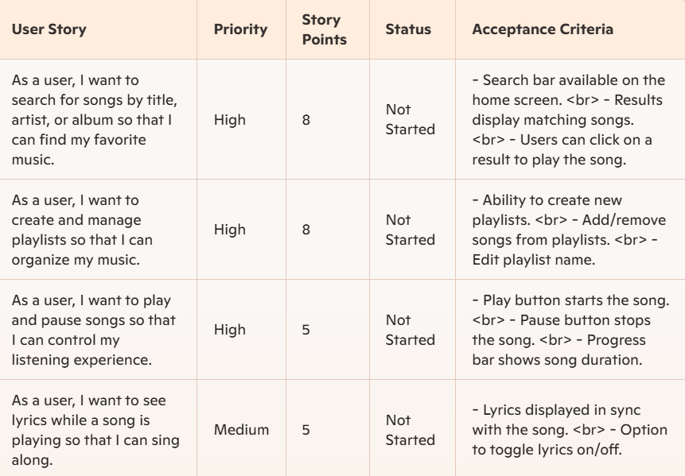

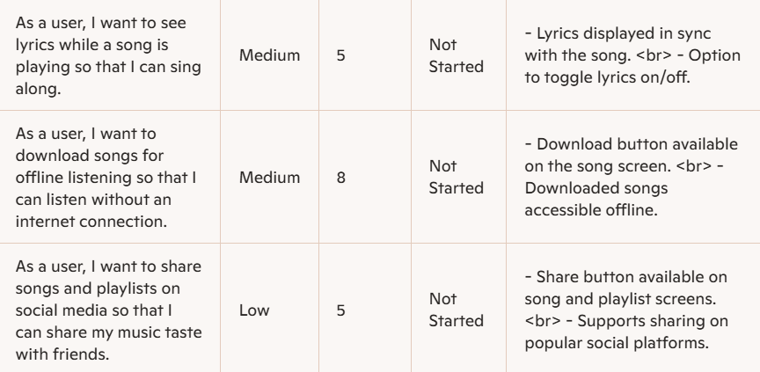

**Project Tracker, Velocity & Burndown Chart**

